**Assignment 2**

The task for this assignment involves the creation of an art gallery experience in VR. There are two rooms made: a waiting room and the art room.

**Controls**

The controls for this VR simulation use the standard simulated VR controls for keyboard.

|  |  |
| --- | --- |
| Action | Key |
| Control camera | Hold right mouse button |
| Control left controller | Hold SHIFT or press T to toggle |
| Control right controller | Hold SPACEBAR or press Y to toggle |
| Pan around device | Move the mouse |
| Move device forward/back | Mouse wheel |
| Rotate device | Hold CTRL and move the mouse |
| Reset device’s position and rotation | Press V |
| Interact with objects | While holding SHIFT or SPACEBAR, press G |
| Bring up reset menu | While holding SHIFT or SPACEBAR, press N |

**First Room**

The first room serves as a waiting room or sitting area, as well as for the starting position of the player when they first load the VR scene. To simulate such an environment, objects such as chairs, couches, plants, TV displays, and some consumables have been placed throughout the room.

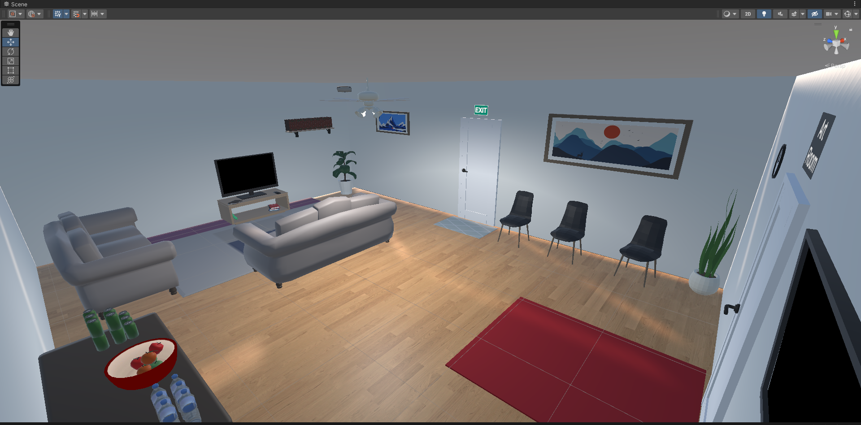

Figure - Overall look of the waiting room

To further enhance the ambience and the relaxing atmospheres, speakers have been placed on the room corners that play classical music. The music starts playing as soon the scene is loaded and plays on loop.

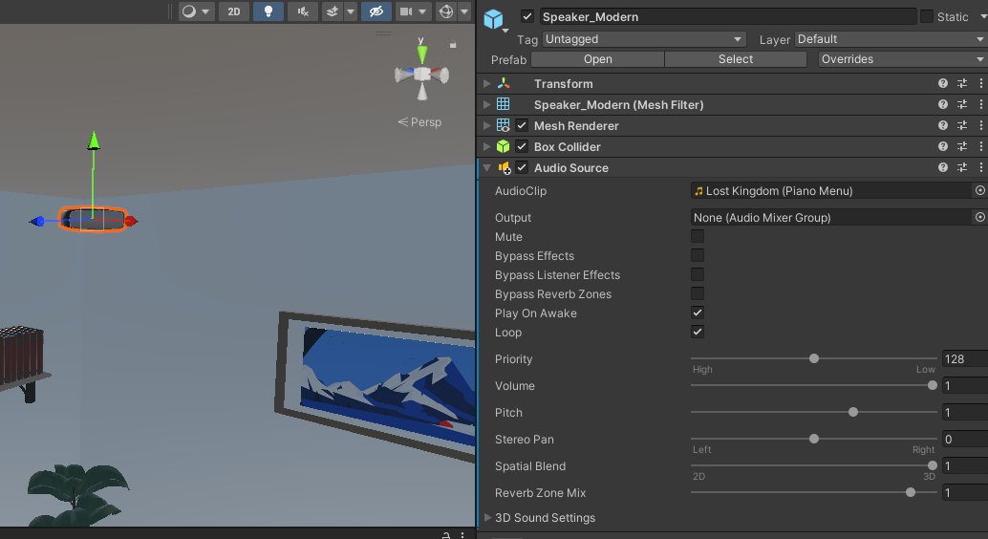

Figure - Speaker with an Audio Source component

Attached to the room ceiling is a ceiling fan that serves to both cool down the room as well as acting as a lighting source. A spotlight object is attached to the fan that illuminates the room. To adjust to the design of the ceiling fan lights while also reducing the number of light sources for performance, a single spotlight object is attached to the center between all four light bulbs attached to the fan and the spotlight was given a relatively high radius. This makes it look as if the whole room is illuminated as opposed to just a limited area directly under the fan.

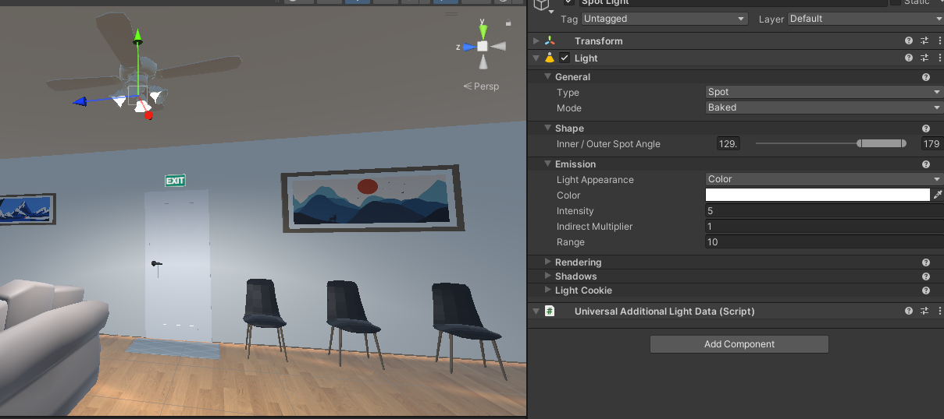

Figure - Spotlight on the ceiling fan

Within this room, there are two doors. The first door is labeled as “Exit” and cannot be interacted with. It is there to add to the immersion of being in an actual room in a structure. In real life, you don’t just spawn in a room with no exit. The second door is used to navigate to the art room and has been labeled as such. I added these labels so that the player knows where to go and where does the doors lead.

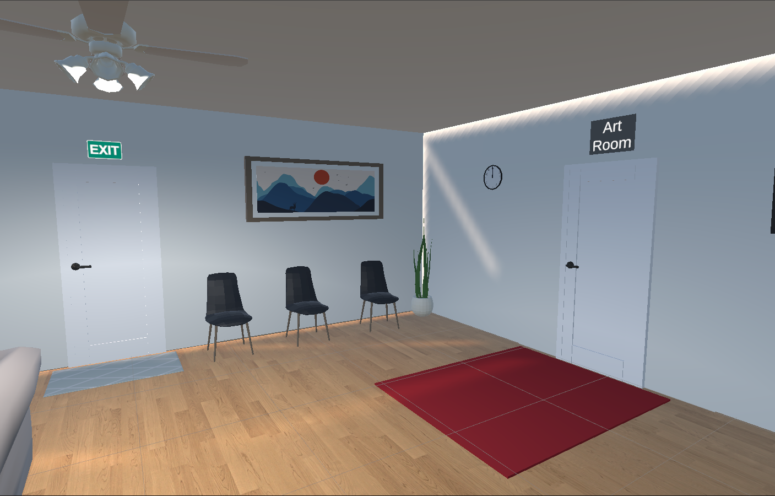

Figure - The exit and art room doors

To add to that, these doors are also accompanied by different rugs. These rugs serve a dual purpose. The first is as a teleportation anchor that the player can use to move around the room. The second is to prioritize the player’s attention and grab their gaze (or to reduce it). The rug under the exit door, for example, is colored gray and is of smaller size compared to the carpet under the art room door. This is by design so as not to steal the player’s attention away from the art room. In contrast, the rug under the art room is colored red to really grab the player’s attention. The size of this rug is also significantly larger on purpose to create the sense of importance to the player. It is almost as if telling the player that this is where the main event happens.

**Second Room**

The second room is the art room. It has objects that you would normally find in an art gallery in real life. This includes hung paintings and sculptures placed on pedestals.

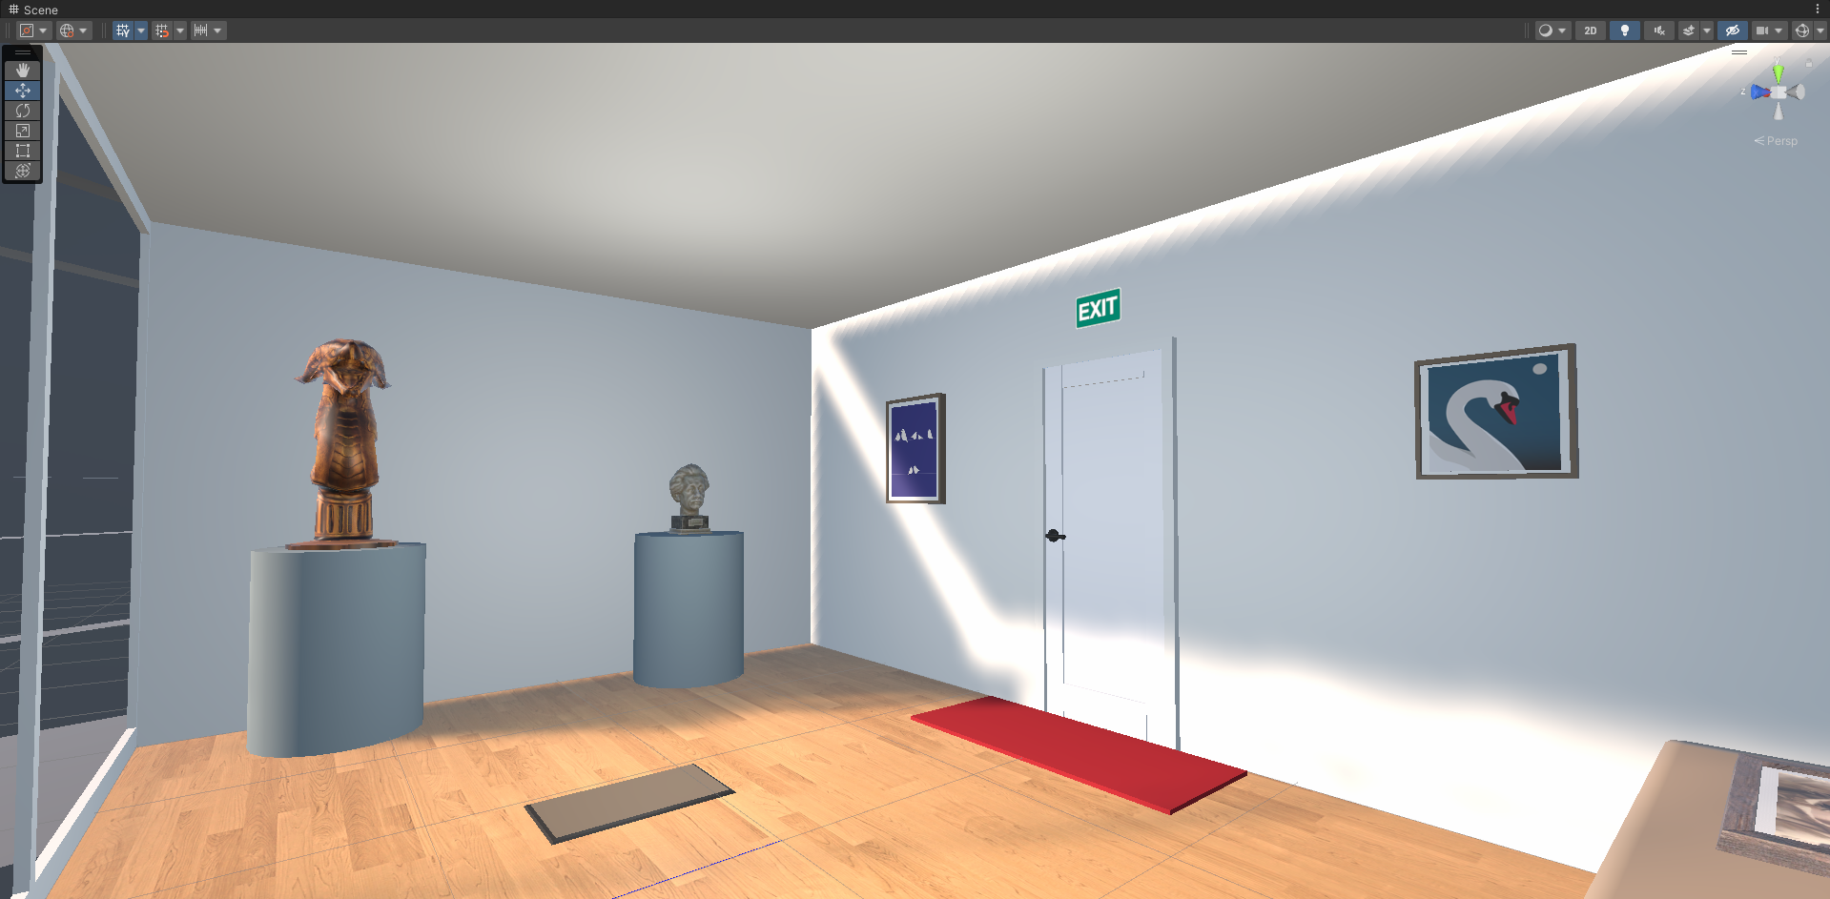

Figure - The art room

The lighting for this room comes mainly from the ambient lighting of the scene, however a directional light object is placed on the room ceiling to correct the lighting that comes from the window.

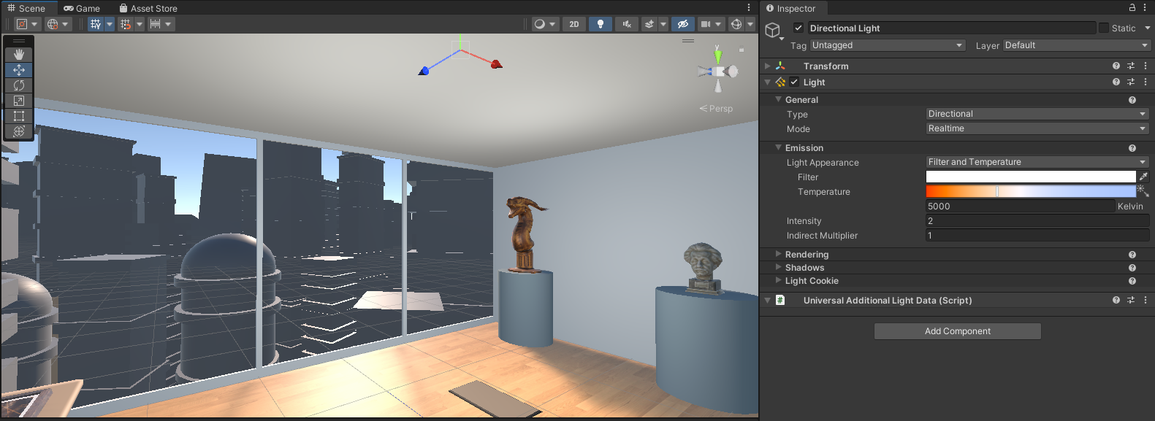

Figure - Directional light on the art room

Like the waiting room, rugs have been placed throughout the room as well. They are also used to help the player navigate the room by acting as teleportation anchors. Looking at Figure 7, the rug placed directly under the exit door is colored red. Its size is also significantly smaller compared to the red carpet seen in the waiting room. This is used to help the player to tell the player that the exit door in the art room leads them to the waiting room. The exit label is also attached on top of the door to inform the player that this door can be used to exit the art room.

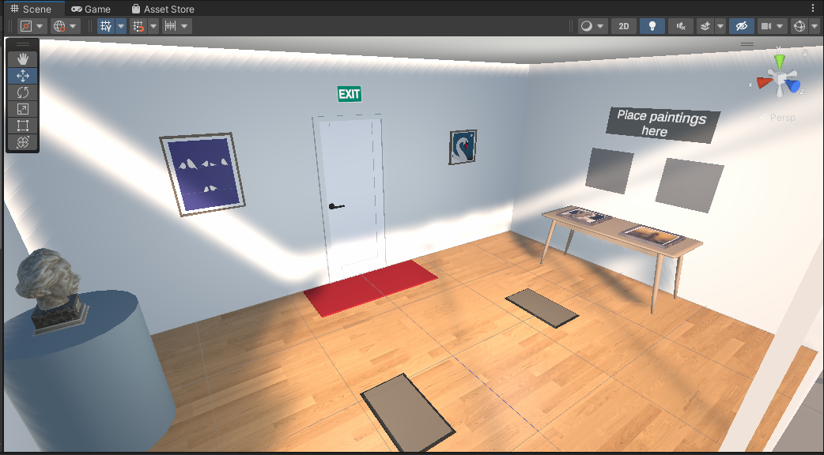

Figure - Rugs spread across the art room

**Interactable Objects**

There are several objects that the player can interact with in both rooms. In the waiting rooms, for example, the player can interact with the drinks provided on the table (Figure 8) or the books on the shelves and on the TV cabinet (Figure 9).

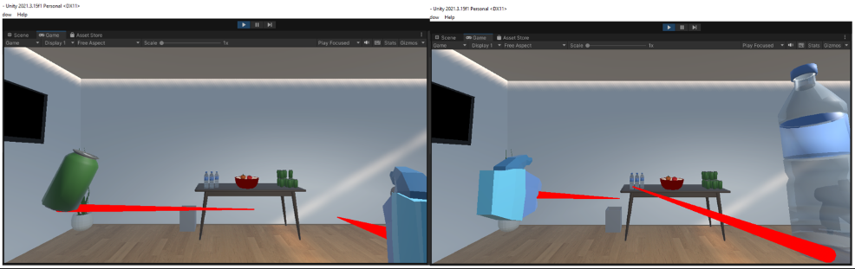

Figure - Player can interact with the consumables on the table

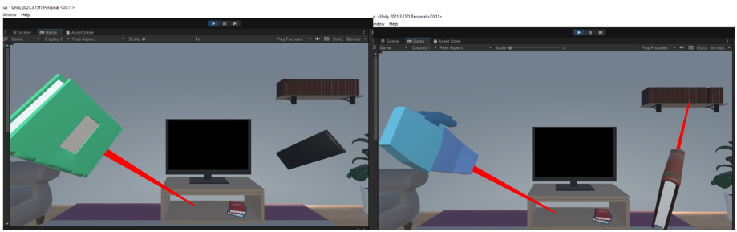

Figure - Player interacting with the items near the TV area

The player can also interact with the door leading to the art room to enter the art room.

In the art room itself, the player can interact with the sculptures on the pedestals (Figure 10) or try to place one of the paintings on the table to be hung on the wall (Figure 11).

Figure - Player can pick up sculptures from their pedestals and place them back

To indicate where on the wall the player can place the paintings, a square patch of the wall is colored dark gray and when the player brings a painting near it a blue highlight of where the painting will be placed is displayed. Additionally, a label is given on top of the square patches to tell the player that they can place their pantings there. This can be seen on Figure 11.

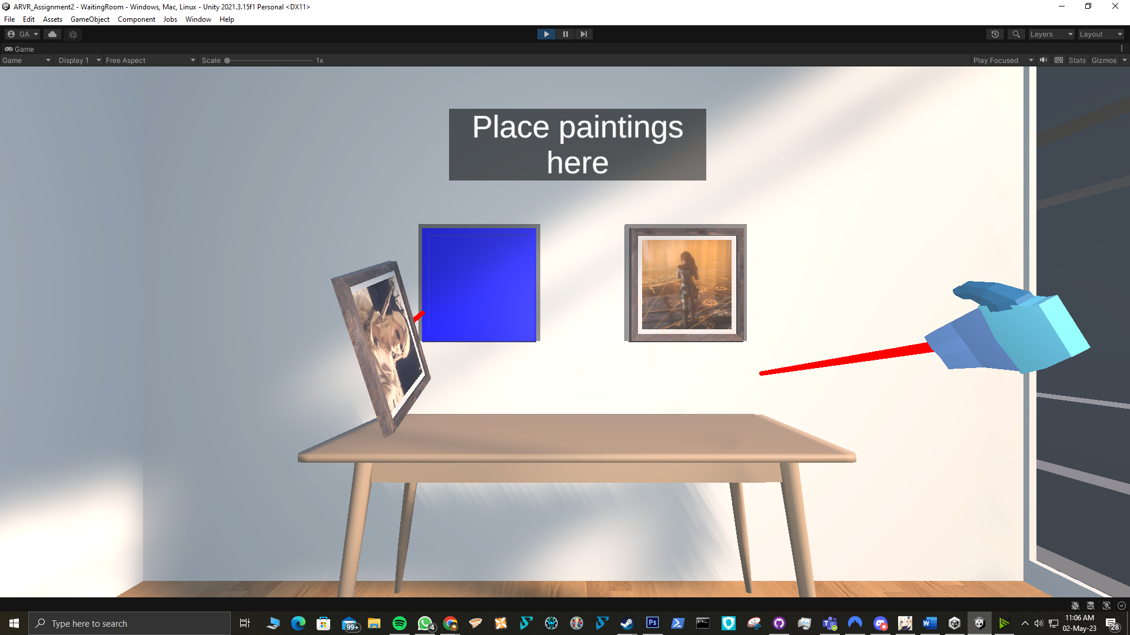

Figure - Player can place paintings on the wall

**User Interface**

UI elements such as canvas, text, and buttons was utilized to enhance the user experience. When the player first loads the scene, a text box appears to inform the player on what they can do. By pressing the button this message will be dismissed.

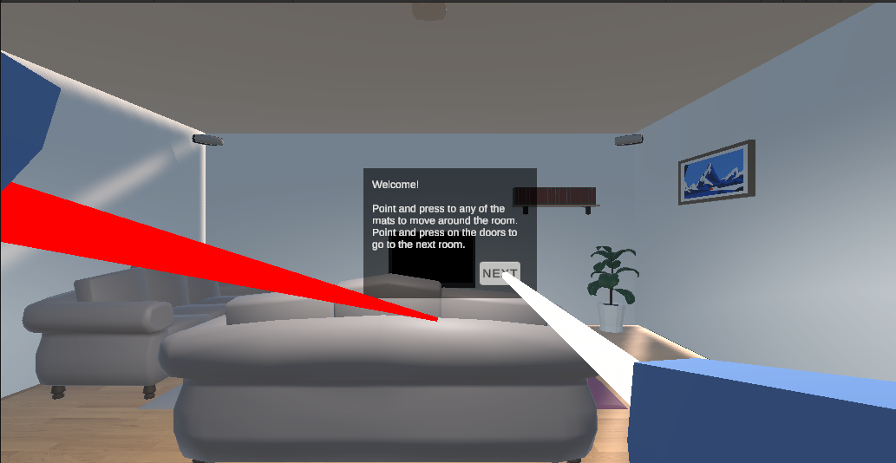

Figure - Start up message user interface

They can also press the N key to get the option to reset the scene.

Figure - UI display to reset the scene

These UI components are placed in the camera screen space, which means it will always be in the same place on the screen and will follow the player no matter where they are. This has the added benefit of allowing the player to reset the scene whether they are currently in the waiting room or art room. Additionally, certain reticles will be displayed when the player points to a door that they can interact with (as shown in Figure 14). This is to tell the player they can interact with it. The laser pointer also changes color from red to white to indicate possible interactions as seen in Figures 10 and 12, for example.

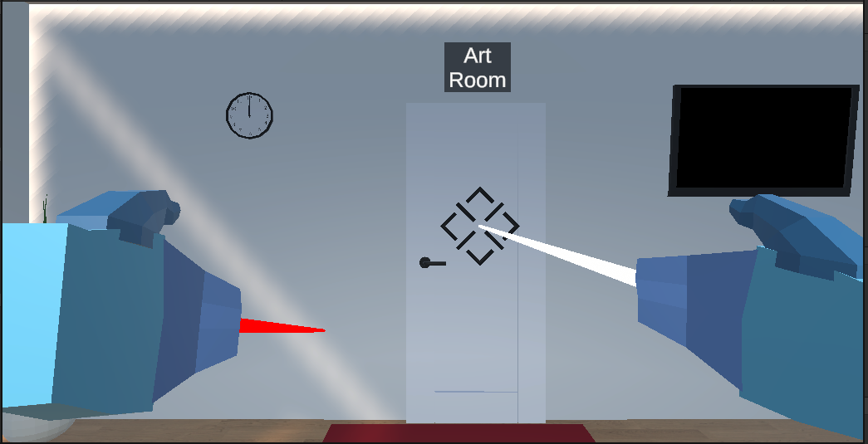

Figure - Reticles when pointing to the art room door

A small preview is also provided to placeable objects during placement so the player knows they can place the objects there. This is seen when placing sculptures and paintings as seen in Figures 10 and 11 respectively.

**Assets Used**

|  |  |
| --- | --- |
| Asset | Credit |
| Albert statue | StormBringer Studios - <https://assetstore.unity.com/packages/3d/props/interior/free-statue-pack-152443> |
| Golden Dragon Statue | 3dFoin - <https://assetstore.unity.com/packages/3d/props/interior/golden-dragon-statue-63132> |
| Picture frames with photos | 3Dfrk - <https://assetstore.unity.com/packages/3d/props/interior/picture-frames-with-photos-106907> |
| Bowl | Robot Skeleton - <https://assetstore.unity.com/packages/3d/props/interior/plates-bowls-mugs-pack-146682> |
| Ciri painting | My own in-game screenshot – credits to CDProjekt RED for the Witcher 3 game |
| Lara Croft painting | My own in-game screenshot – credits to Crystal Dynamics for the Rise of the Tomb Raider game |
| Exit sign image | <https://cdn.shopify.com/s/files/1/0092/8789/3051/products/198_1024x1024.jpg?v=1629122234> |
|  |  |

Everything else comes from the assets given in the labs.